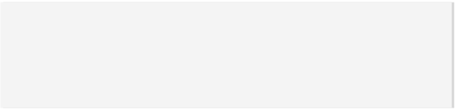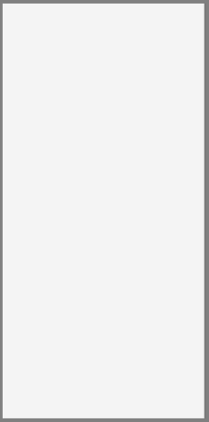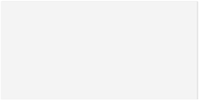

Accomplished, Creative and enthusiastic software developer with 7+ years of experience excels in every stage of the life cycle of software development, including UI/UX design, coding, debugging, testing, and deployment. With a get-it-done, on-time spirit, and years of experience implementing and adapting technically sophisticated online web applications. Currently I'm specialized in responsive web application such as Angular 7 with .NET Core in Microservice Architecture with Docker, also I am participating with Azure and Mobile Programming.

* Adept at overseeing all phases of software development lifecycle, from design and documentation to implementation.
* Exceptional experience working in fast-paced, deadline-oriented environments.
* Strong team leader with extensive background managing and training junior employees.
* Ability to quickly learn new concepts and technologies. and analyze Complex Technical Information.

**SUMMARY**

**Senior Software Developer (.Net Full Stack - Fulltime)**

Mckesson Corporation Atlanta, GA

* Lead and build new enterprise level SPA from scratch by using Angular 7/Rxjs/Ngrx/GraphQL, Bootstrap and JQuery as front end, design new real-time data chart in websocket.
* Lead and build new enterprise level Restful Services in .Net Core Web API with EntityFramework Core(Database-first) in multiply layer with DI pattern, implement middleware components such as Logging, Global Error Handler and JWT Auth, etc.
* Research and leverage current service architecture into DDD-oriented microservices with docker container and message-broker.
* Participated in Azure application Service Fabric in cloud programming with Redis and Azure Storage.
* Collaborate with developers, QA, product owner and scrum master to understand prioritize needs and produce high quality software changes.

**Key technologies:** C#/.Net Core Web API/Entity Framework Core/SignalR/OData/Polly/RabbitMQ/Serilog, Angular 7/Rxjs/Ngrx/GraphQL/WebSocket/Bootstrap/Html5/JQuery, SQL Server 2017/Azure DB/Redis, Jira/Bitbucket/Git/TFS, dockerhub etc

**Software Developer (.Net Full Stack - Fulltime)**

McKesson Corporation Atlanta, GA

* Act as full stack developer for delivering enterprice level Asp.Net SaaS web application to healthcare entities by involving in Agile and scrum development process.
* Lead and build responsive design MVVM forms from scratch by using Vue, Bootstrap, javascript/jQuery, etc. The ability to learn, analysis and integrate third party API/tool quickly.
* Develop Restful Service in Web API 2 in .Net 4.5, maintain and enrich the legacy Asp.net webform app, C# backend data integration application with Ado.Net to improve for the internal portal to view the status of services, schedulers and monitors.

*kevinding0218@gmail.com*

*github.com/kevinding0218*

D

R

2010 – 2013 **| Master of Science (M.S) / Computer Science**

University of Dayton, Dayton, OH

2006 – 2010 **| Bachelor of Science (B.S) / Computer Software Engineering**

Nanjing University, Nanjing, Jiangsu, China

*Oct’15*

*Jun’18*

RAN

DING

Senior Software Developer

(.Net Full Stack - Fulltime)

*Jul’18*

*Current*

**WORK EXPERIENCE**

**EDUCATION**

**Programming Languge:** C#/Typescript/Javascript/Java/VB/Python, etc.

**Frontend:** Angular7/VueJs/RxJs/Ngrx/GraphQL, JQuery/Ajax/Bootstrap/Html5/Css/Scss, Nativescript/Ionic, Json/Xaml/Razor, etc.

**Backend:** Asp.Net Core Web API/Web Form/SignalR/.Net MVC/Node.js/NestJS, EF Core/OData/Polly/Serilog/Ado.net/Linq/RabbitMQ/Serilog, Xamarin, etc.

**Database:** MS Sql Server/MySQL/Redis/Azure Storage/Firebase/Mongo/Sqlite, etc.

**Other:** Jira/Bitbucket/Git/TFS/Github/Azure App Service, Npm/Nuget/Webpack/AngularCLI, Sql Profiler/Redgate/Postman/ Crystal Report, SSIS/SSRS Reporting Service, IIS, etc.

**SKILLS**



**EVENTS AND AWARD**

* **NgAtlanta 2019 Conference and Workshop**
* **Employee of the Month**

Macro Helix IT Department Aug 2016

* **Employee of the Month**

Macro Helix IT Department Feb 2016

*Feb‘10*

*Aug’10*

*Sep’12*

*May’13*

*May’13*

*Sep’15*

**WORK EXPERIENCE Cont…**

**Software Developer (.Net Full Stack - Fulltime)**

* Work on high-volume, large-scale(>5TB) databases with writing complex store procedure, optimizing data access and improving database performance.
* Knowledgeable in Healthcare (340B program)/EDI transform business workflow.

**Key technologies:** C#/.Net 4.5/.Net Web API/Ado.Net, Vue/Bootstrap/Html5, SQL Server 2017, Jira/Bitbucket/Git/TFS etc

**Software Engineer (.Net and Java - Fulltime)**

Ravello Insurance Technology Sandy Springs, GA

* Developed enterprise level Claims/Policy/Billing web applications by using ASP.NET(Webform)/Java(Spring) for leading insurance provider.
* Upgraded legacy application by integrating AngularJS(1.2) and Bootstrap 2 with JQuery/Ajax to SPA.
* Drove continual improvement to system architecture by refactoring old legacy code.Fix and improve the compatibility issue between different browsers.
* Troubleshot and resolved bugs all over frontend/backend/sql server to ensure optimized product environment.

**Key technologies:** C#/VB/Asp.Net Webform/.Net MVC 3/Spring MVC/AngularJS/Bootstrap/Javascript/JQuery/Ajax/SQL Server 2008R2

**Software Developer (.Net Silverlight - Volunteer)**

Leap American LLC Mason,OH

* Design and build user-friendly music recommendation web application by using C#/.net Silverlight 5.
* Worked in Ado.Net to manage data model and schema, writing store procedure to implement the data transaction from database level.
* Worked closely with the Lead Developer and Architecture to ensure architectural integrity and product quality.

**Key technologies:** C#/.Net Silverlight 5/XAML/IIS 7.5/Javascript/JQuery/AJAX, .Net music player

**C++ Developer(QT - Intern)**

Guodian Nanjing Automation Co., Ltd. Nanjing, Jiangsu, China

* Implemented using C++/QT and compile among multiple types of operating systems to develop a real-time communication embedded system.
* Collaborated with the team well and capable of handling complicated social relationship.
* Worked closely with Lead engineer to ensure product quality and documentation.